“当代中国文化影响力生成”
国际论坛征稿通知

当代中国文化和经济的世界影响力存在明显的“不相称性”，针对当代中国文化，我们认为应该尊重文化自身的发展规律，围绕“生成”这一文化发展的根源问题展开讨论，博采众长，集思广益。本论坛由会林文化基金和中国文化国际传播研究院主办。

一、论坛主题：当代中国文化影响力生成
来稿可涉及但不限于：文化影响力的内涵与表现；世界文化影响力生成的关键因素；优秀文化影响力生成的案例研究；制约当代中国文化影响力的原因；等等
二、时间、地点
时间：2017年11月24日（周五）－25日（周六）
地点：北京师范大学京师学堂
会议语言：中文、英语（届时有同声传译）
三、征文截止时间与要求
1. 2017年6月30日前，请将题目、摘要和作者简介发送aiccc@bun.edu.cn，注明回应的分论题，若不相关请注明“其他”。
2. 2017年7月31日前，公布入选名单。
3. 2017年9月30日前，请提交全文至aiccc@bun.edu.cn。
4. 格式：中文正文用宋5号，脚注格式（每页重新编号①），可不含图片和参考文献。
5. 如不单独声明，投稿（只限中文）同时被默认授权主办方可根据需要编辑出版。
四、出版：
中文论文择优收录北京师范大学出版社《“第三极文化”论丛》，或推荐相应学术期刊发表。
五、会务费：
每人会务费1200元，由会林文化基金全额资助。
六、联系方式
联系人：刘江凯；地址：北京市新街口外大街19号，北京师范大学后主楼1732；邮编：100875；电话：010－58805680；邮箱：aiccc@bun.edu.cn。
更多信息，可扫描如下二维码或搜索关注“中国文化国际传播研究院”微信公共号。
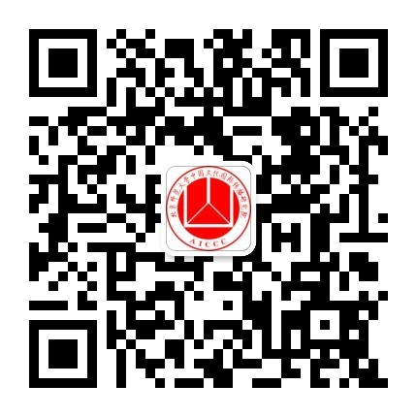

Call for Papers:
“Reach and Influence of Contemporary Chinese Culture”
Sponsored by Huilin Foundation & AICCC, BNU

There is huge incongruity between the influences of contemporary Chinese culture and its economic impact in the world. For contemporary Chinese culture, we believe that we should respect the intrinsic law of cultural development and trigger the discussion and collect wisdom on the fundamental subject, generation of culture.
The proposal for presentation could answer the following topics, but not limited to:
1, Connotation and Representation of Cultural Influence,
2, Key Factors for the Generation of Cultural Influence in the World,
3, Case Studies on the Generation of Prominent Cultural Influences,
4, Factors Limiting Contemporary Chinese Cultural Influence, etc.
We encourage you to bring forward other valuable and related topics from the standpoint of your own areas of research. The papers submitted and approved will be published in the “The Third Pole Culture” conference proceedings or recommended for other related academic journals.

Date and Venue
Date: November 24 - 25, 2017
Venue: Jingshi Academy, Beijing Normal University, China
Working Language: Chinese and English (simultaneous interpretation on site)

Deadlines
1, Proposal:
Please send proposals, including title, abstract (max. 500 words), a short bio, and contact information (address, telephone number, e-mail), to aiccc@bnu.edu.cn, before June 30, 2017. Please specify which topic your paper mainly answers, if it’s not relevant to any topic suggested above1-4, please note as “other”.
2, Notification:
Scholars who have submitted their proposals by the deadline will be notified of their inclusion in to the conference before July 31, 2017.
3, Full Papers:
All full paper should be submitted to aciccc@bnu.edu.cn before September 30, 2017.
4, Format:
Manuscripts should be prepared according to the specifications of the Chicago Manual of Style, 16th edition (Chicago: University of Chicago Press, 2010). Authors are responsible for the accuracy of all quotations and for supplying complete references. All copy, including block quotations, end notes, and reference lists, must be double-spaced, and in Times New Roman font. All footnotes must be converted to endnotes. It is strongly preferred that submissions remain between 6000 and 9000 total word count, though it is understood that this is not always possible.

Publication
Selected papers will be considered to be published in a special issue of International Communication of Chinese Culture.

Fee
The registration fee is 1,200 CNY per scholar which willl be fully sponsored by Huilin Foundation.

Contact
Dr. Jackiee Liu Jiangkai
Add: Beijing Normal University, No.19, Xinjiekouwai St., Haidian District, Beijing, China
Phone: 86 10 58805680
Post Code: 100875
Email: aiccc@bnu.edu.cn

